Pivotal Cloud foundry

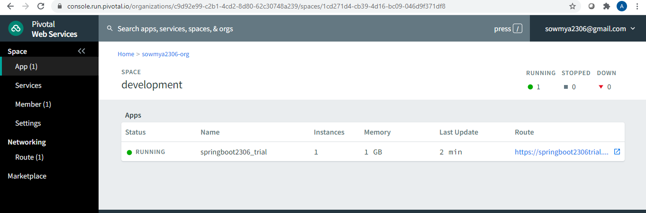

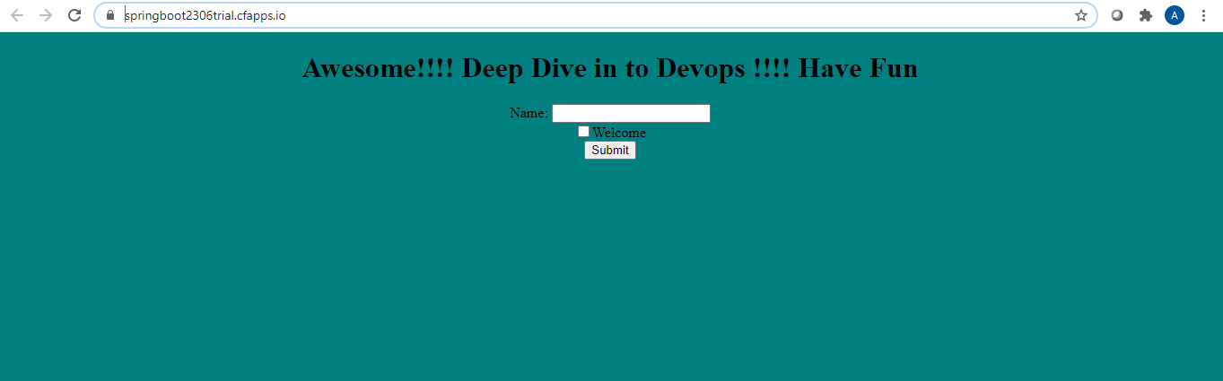

**Groovy Script for deploying to PCF**

**node{**

**stage('git checkout'){**

**git credentialsId: 'Git', url: 'https://github.com/sowmyatcs2306/Devops_BootCamp.git'**

**}**

**stage('code build and test')**

**{**

**def mavenHome = tool name: 'maven_default',type: 'maven'**

**echo mavenHome**

**def mavenCMD = "${mavenHome}\\bin\\mvn"**

**bat "${mavenCMD} clean package"**

**}**

**stage('deploy to pcf')**

**{**

**withCredentials([usernamePassword(credentialsId: 'pcf', passwordVariable: 'pcf_pass', usernameVariable: 'pcf_user')]) {**

**pushToCloudFoundry(**

**target: 'https://api.run.pivotal.io',**

**organization: 'sowmya2306-org',**

**cloudSpace: 'development',**

**credentialsId: 'pcf',**

**,**

**manifestChoice: [**

**value: 'jenkinsConfig',**

**appName: 'springboot2306_new',**

**appPath: 'target\\devops-test-app-0.0.1-SNAPSHOT.jar'**

**]**

**)**

**}**

**}**

**}**

**App deployed toPCF**

